** **

**UNIVERSITÄT ZU KÖLN BIOZENTRUM ZOOLOGISCHES INSTITUT TIERPHYSIOLOGIE**

**Seminars in Neurosciences**

**Wednesday,** **October 4th 2017**venue:***Lecture hall 0.024, Biocenter, Zülpicher Str. 47b***

**9:30 a.m. Prof. Karen A. Mesce,**Department of Neuroscience and Entomology,   
University of Minnesota St. Paul,  
Minnesota, USA  
  
“***Small Steps and Larger Strides in Understanding  
Locomotor Circuits and   
Their Functional Recovery after Injury***”.

**Host: RTG-NCA  
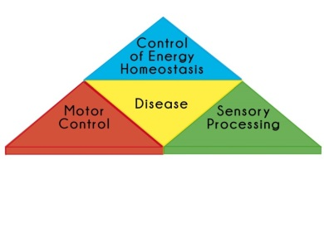**  
**RTG-NCA**: Neural Circuit Analysis on the cellular and subcellular level  
**http://rtg-nca.uni-koeln.de**